Exp 12

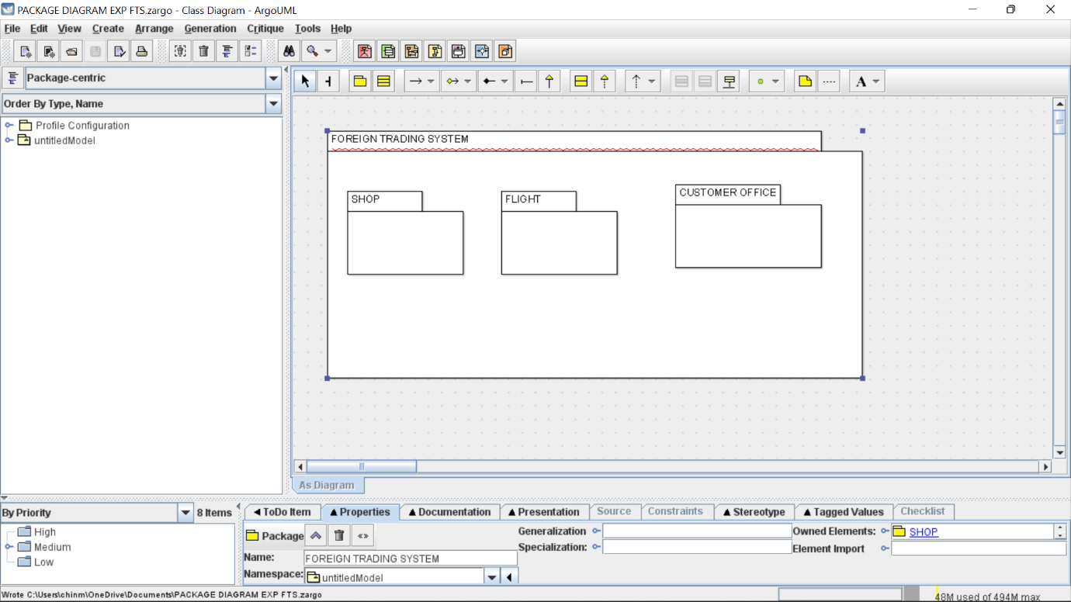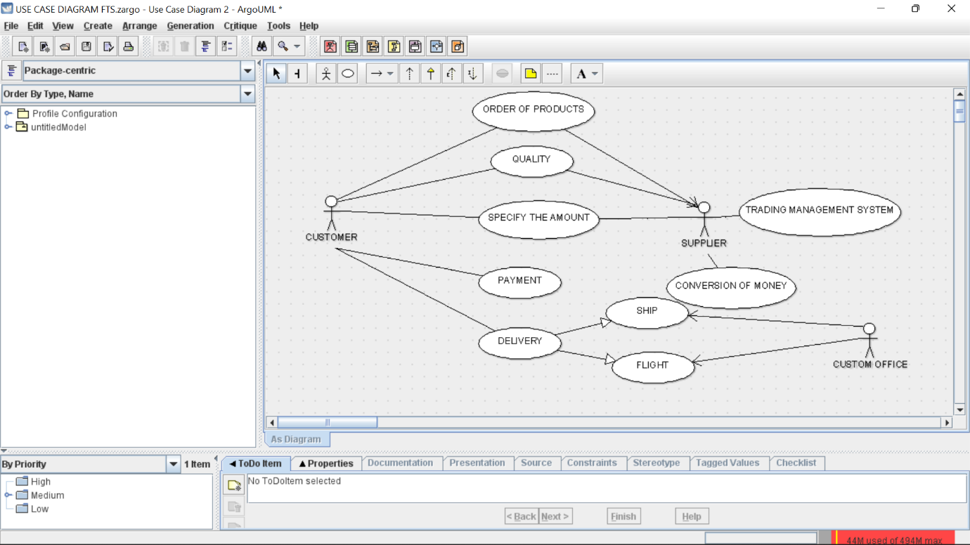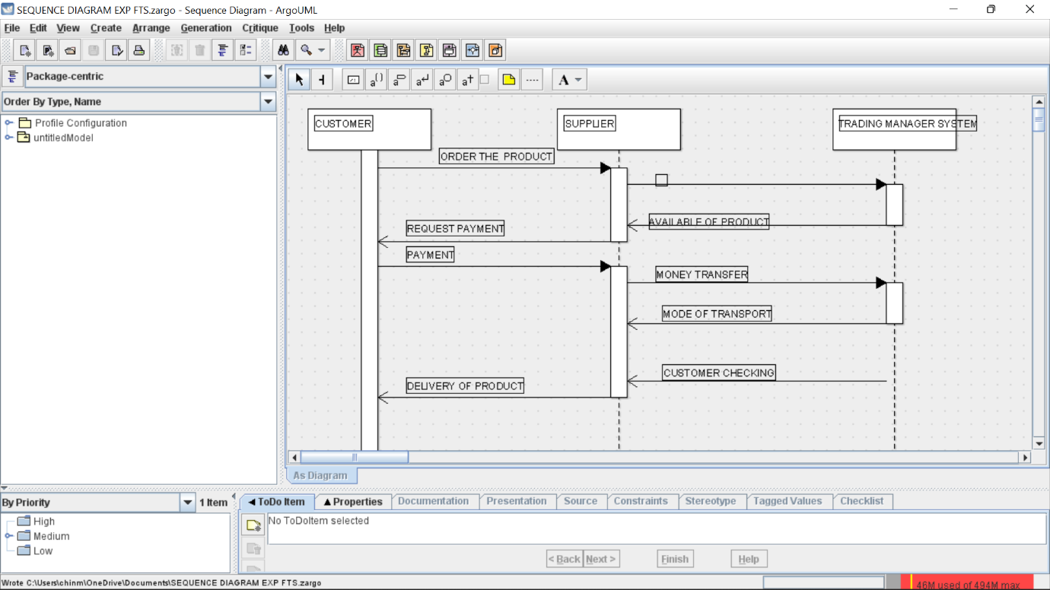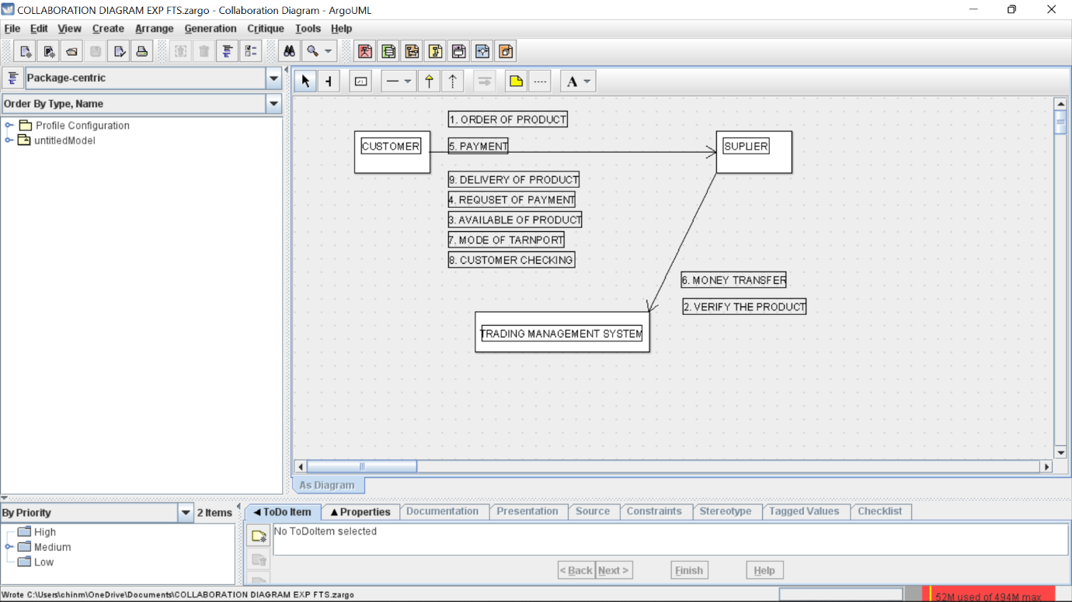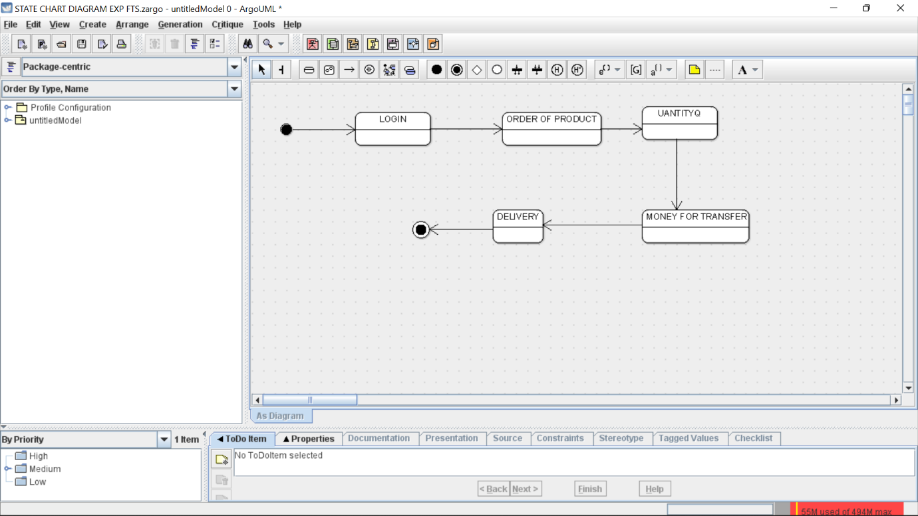skel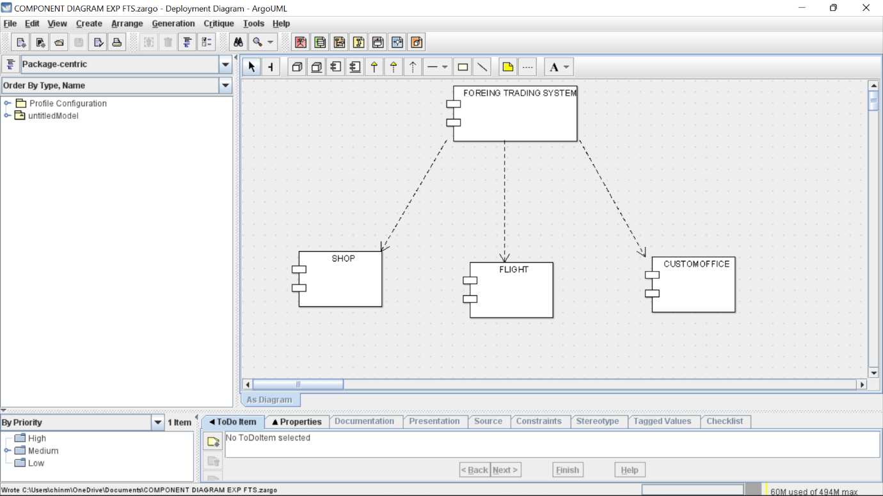

Skeleton\n code

import java.util.Vector;

public class CUSTOMER {

public Integer newAttr;

public Integer QUALITY;

public Vector myTRADING MANAGEMENT SYSTEM;

public void PAYMENT() {

}

public void DELIVERY() {

}

public void TRANSPORT() {

}

}

import java.util.Vector;

public class SUPPLIER {

public Integer PRODUCTSUPPLY;

public Vector myTRADING MANAGEMENT SYSTEM;

private void TTANSFER() {

}

}

public class TRADING MANAGEMENT SYSTEM {

private Integer PRODUCT;

public Integer AMOUNT;

public void TRANSPORT() {

}

public void DELIVERYPRODUCT() {

}

public void MONEY() {

}

}